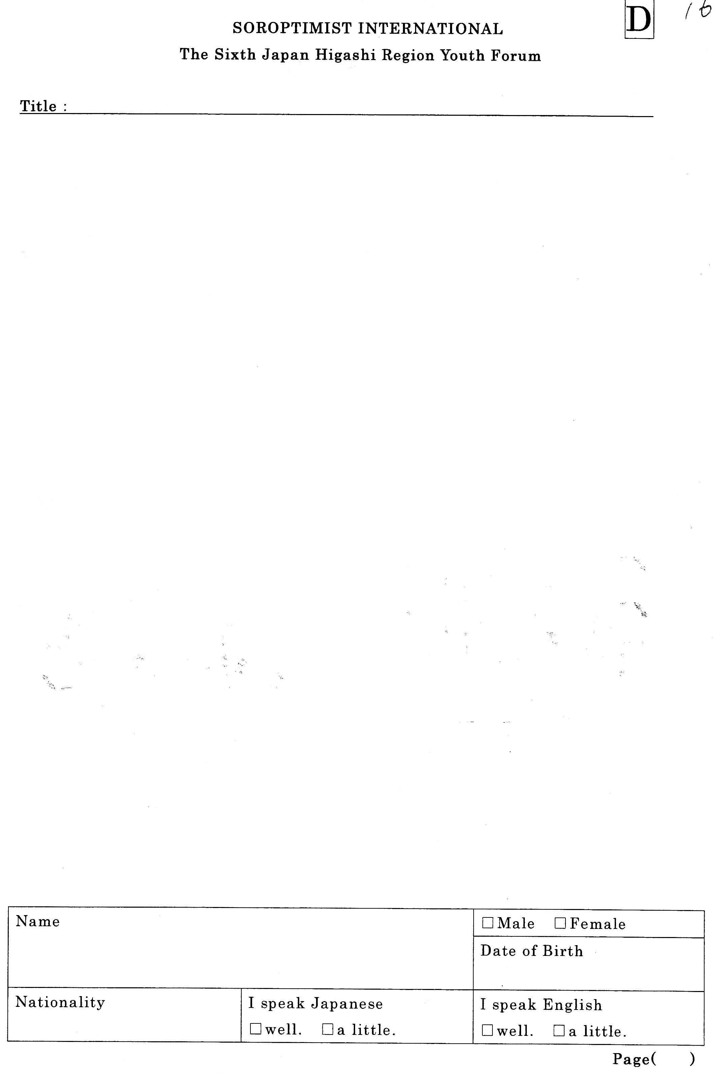
Ｔｈｅ ２8ｔｈ NAGAOKA Ｙｏｕｔｈ Ｆｏｒｕｍ Ｅｎｇｌｉｓｈ Ｓｐｅｅｃｈ Contest
for Senior High School Students

